**Skillovilla Capstone Project**



**ShopNest Store (Nexusgoods Superstore Project) -**

**Power BI Capstone**

*Submitted by:*

*Preeti Chandrakar*

*(DAY-202401-1)*

*23rd June 2024*

# **Introduction**

ShopNest stands as the leading department store in the e-commerce marketplaces in Portugal. Serving as a seamless link, it connects small businesses from various regions in Portugal to channels, streamlining the process with a single point of contact.

This report provides a comprehensive analysis of various aspects of Nexusgoods Superstore, including product ratings, delayed orders, sales patterns, and payment methods. The insights are derived from customer reviews, sales data, and order statistics to offer a detailed overview of the superstore's performance.

## **1.** **Top Categories by Total Price:**

* **Question Statement:** Identify and visually represent the top 10 product categories by total sales.
* **Visualization:**

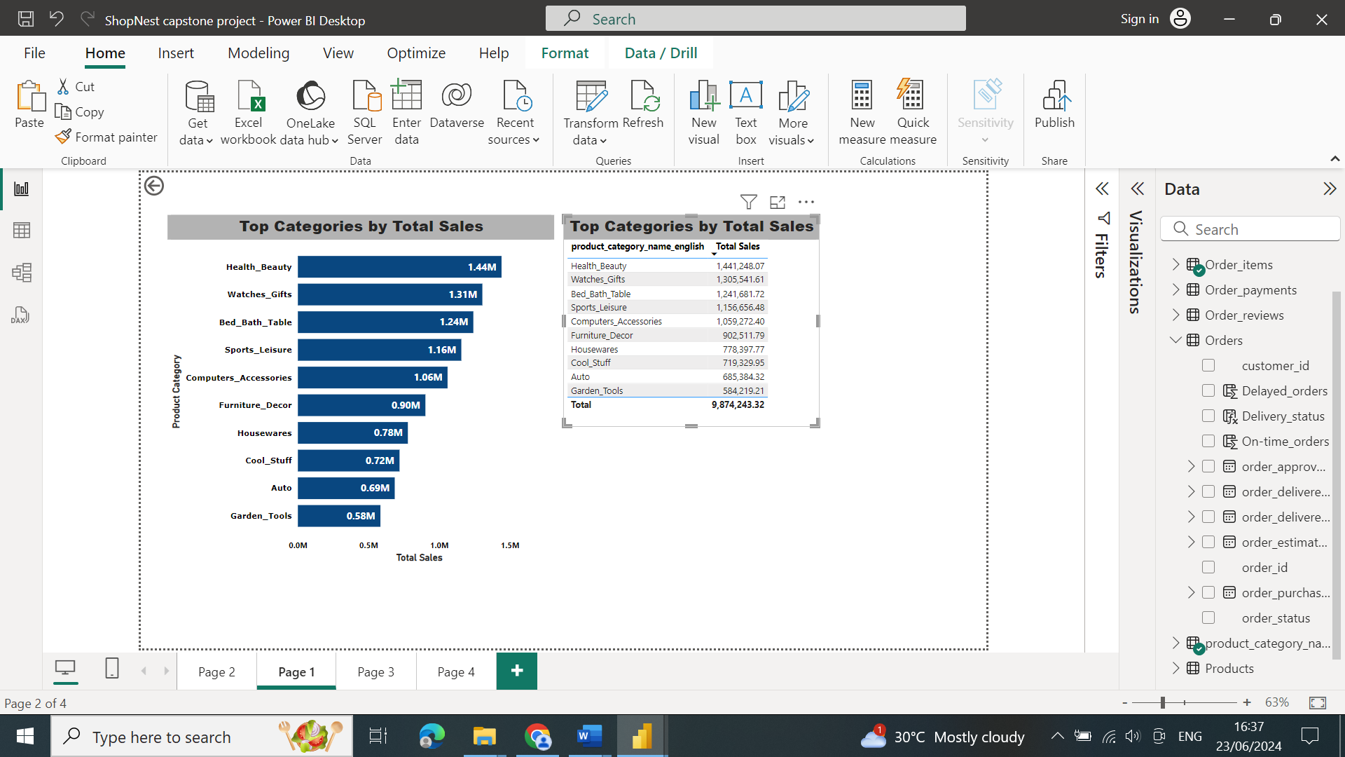

* **Explanation:**
  + The visual clearly shows the top 10 product categories by total sales. This helps in identifying which categories **contribute the most to the revenue.**
  + By observing the length of the bars, we can see the distribution of sales among the top categories. Some categories might have significantly higher sales than others, indicating **their popularity or higher price points.**
  + The visual can reveal if sales are concentrated in a few categories or evenly distributed among the top 10. This is important for understanding **market dynamics and potential dependency on specific categories.**

## **2. Delayed Orders Analysis:**

* **Question Statement:** Determine the number of delayed orders in each category. An order is considered delayed if the actual delivery date is later than the estimated delivery date.
* **Visualization:**

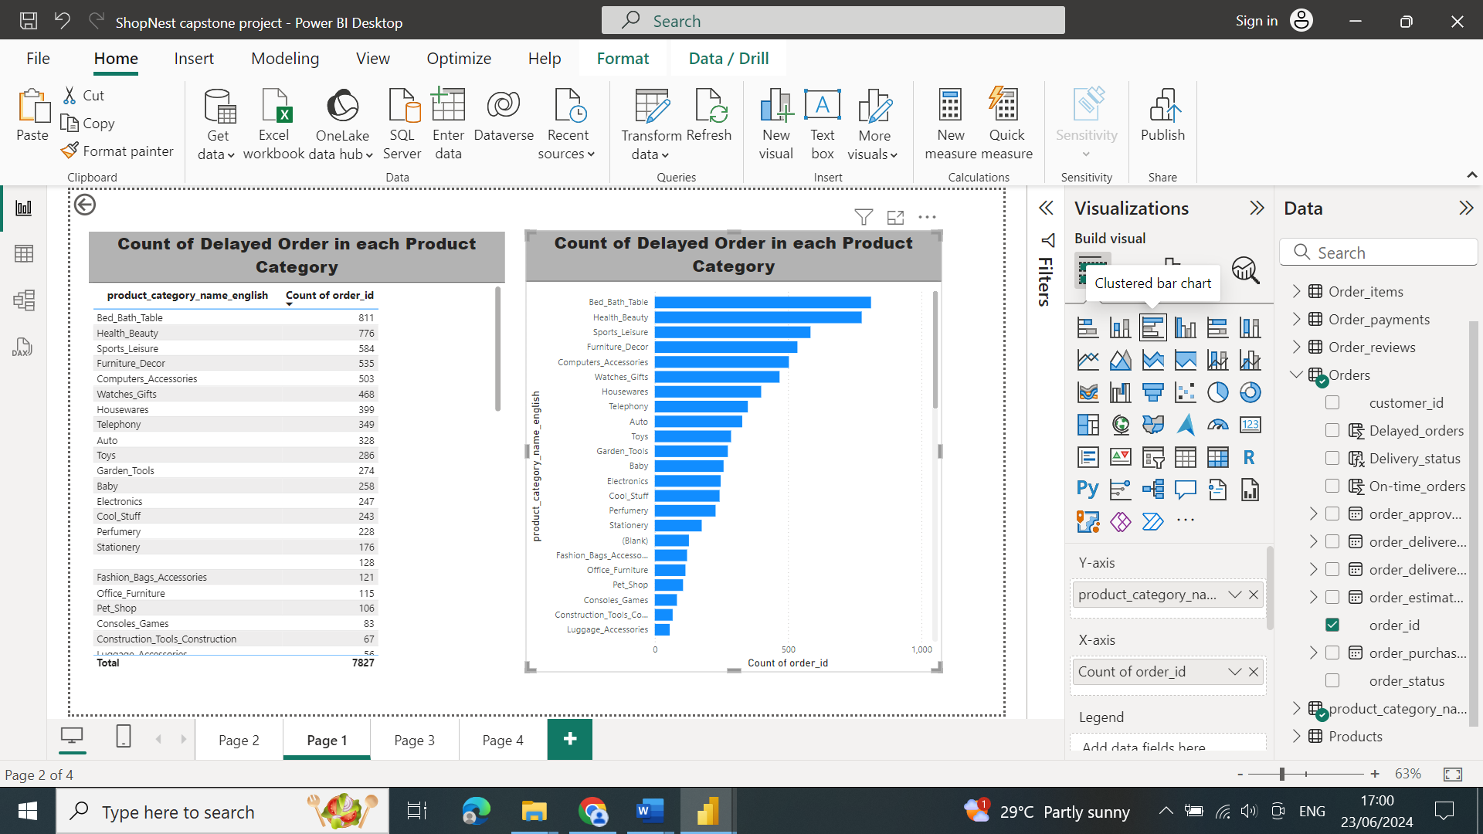

* **Explanation:**
  + This section provides information about the products with the most delayed orders**. Bed, Bath & Table** had the highest number of delayed orders, with a total of **811 orders** delayed across Nexusgoods Superstore.
  + The data clearly shows which product categories have the highest number of delayed orders. This helps identify **potential areas where the supply chain or delivery process may need improvement.**
  + The Data can provide insights into the **operational efficiency** of different product categories. Categories with **fewer delays may indicate better inventory management, supplier reliability, or efficient logistics**.

## 3. Monthly Comparison of Delayed and On-Time Orders:

* **Question Statement:** Create a dynamic visual that compares the number of delayed orders to the number of orders received earlier for each month. Utilize the drillthrough cross-report feature to provide a detailed analysis of late and on-time deliveries.
* **Visualization:**

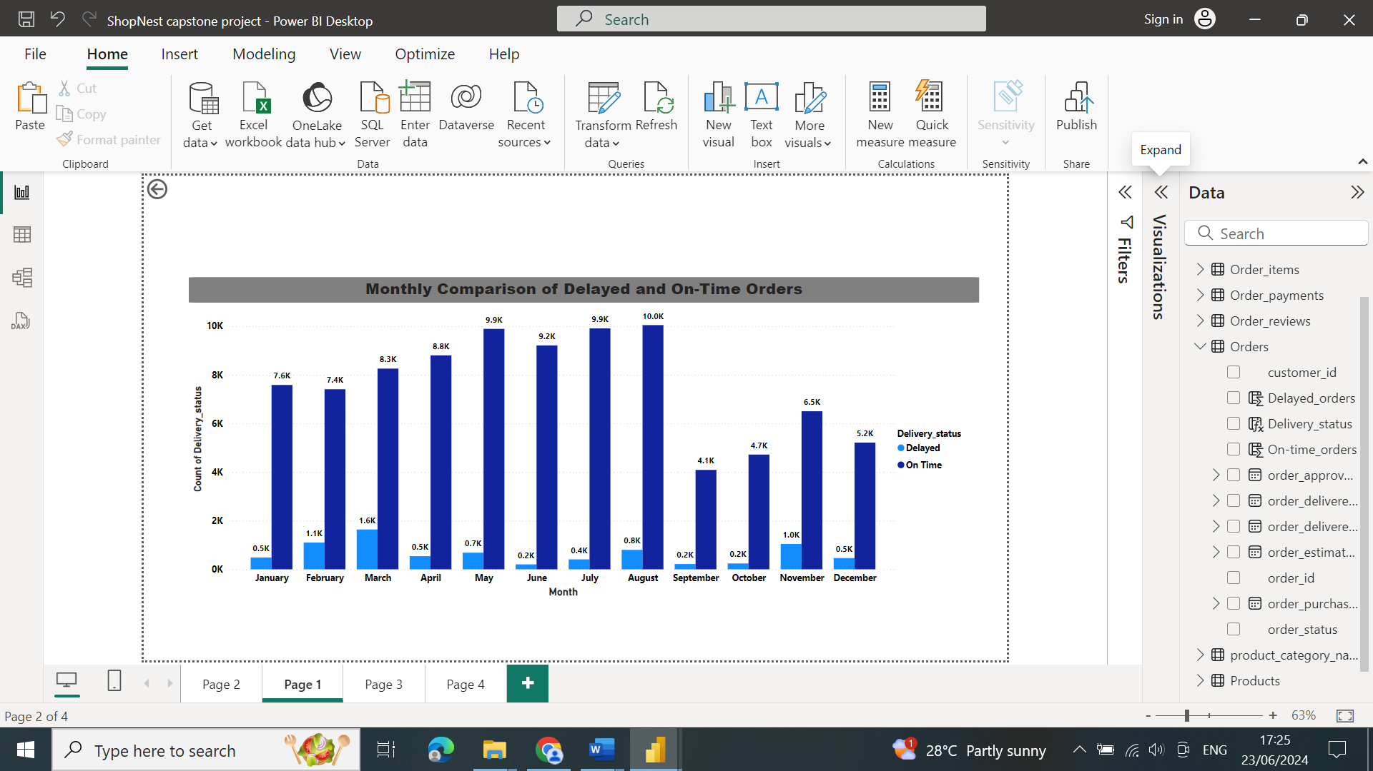

* **Explanation:**
* This analysis provides statistics on the number of **delayed orders** in relation to quarterly sales. In the first quarter of 2018, which includes **January, February, and March, a significant number of products were delayed.**
* This graph displays the number **of on-time orders** in relation to quarterly sales. In the second quarter of 2018, which included **April, May, and June, most of the orders were delivered on time.**
* The comparison between **delayed and on-time orders** can highlight periods of high efficiency and periods that may need **operational improvements**.

**Drillthrough Analysis**:

The drillthrough feature allows for a detailed analysis of specific months, enabling a deeper understanding of the factors contributing to delays or timely deliveries.

This clustered column chart compares the number of delayed orders to on-time orders for each month. The X-axis represents each month, while the Y-axis shows the count of orders. From the chart, we observe that in the month of March, there is a significant spike in delayed orders, which might indicate operational challenges or external factors affecting delivery performance during these months. Conversely, in September and October, the number of on-time orders surpasses delayed orders, indicating improved efficiency. The ability to drill through from this chart to a detailed report page provides a valuable tool for investigating the specific reasons behind these trends. For instance, by drilling through on March, we can analyze individual orders to identify common issues causing delays and address them to improve future performance."The ability to drill through from this chart to a detailed report page provides a valuable tool for investigating the specific reasons behind these trends. For instance, by drilling through in March, we can analyze individual orders to identify common issues causing delays and address them to improve future performance.

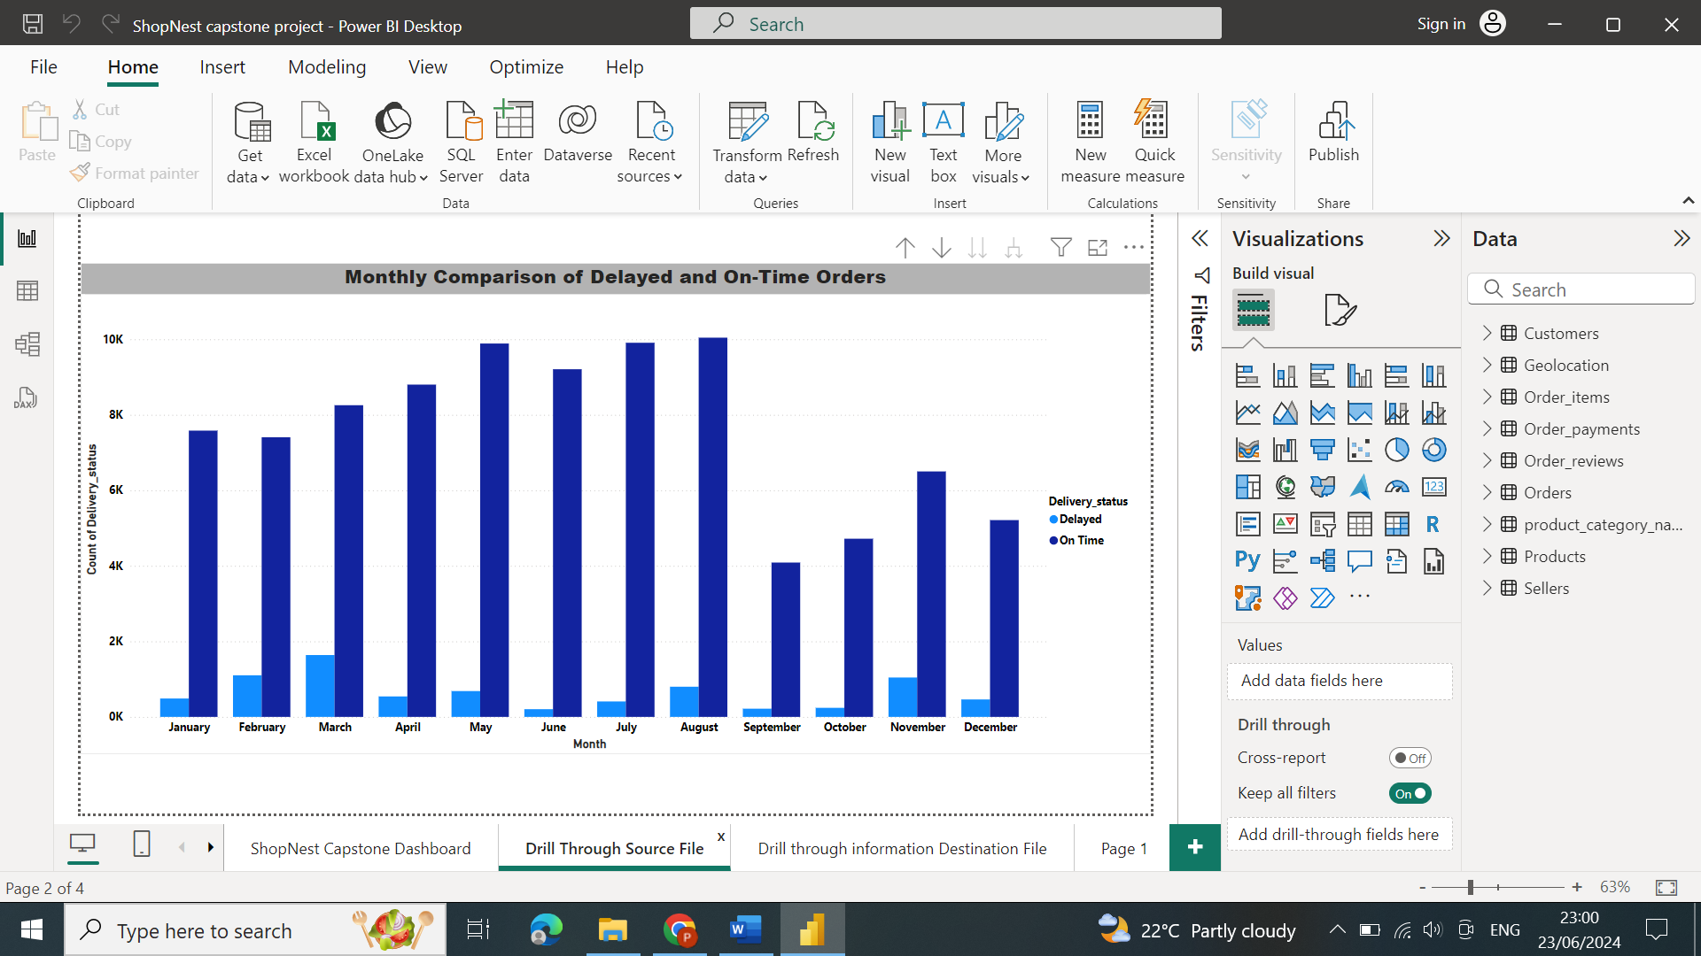

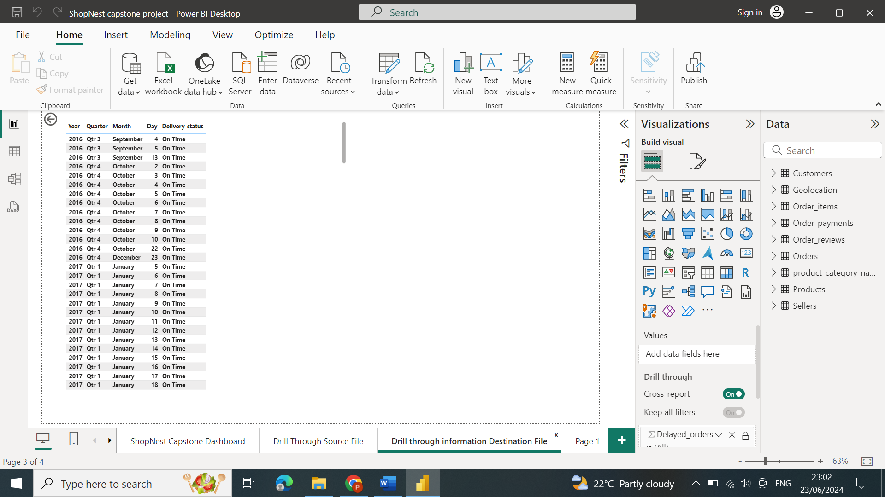

## **4. Payment Method Analysis:**

* **Question Statement:** Analyze the most frequently used payment methods by customers using a visually appealing representation, such as a pie chart or other suitable visuals.
* **Visualization:**

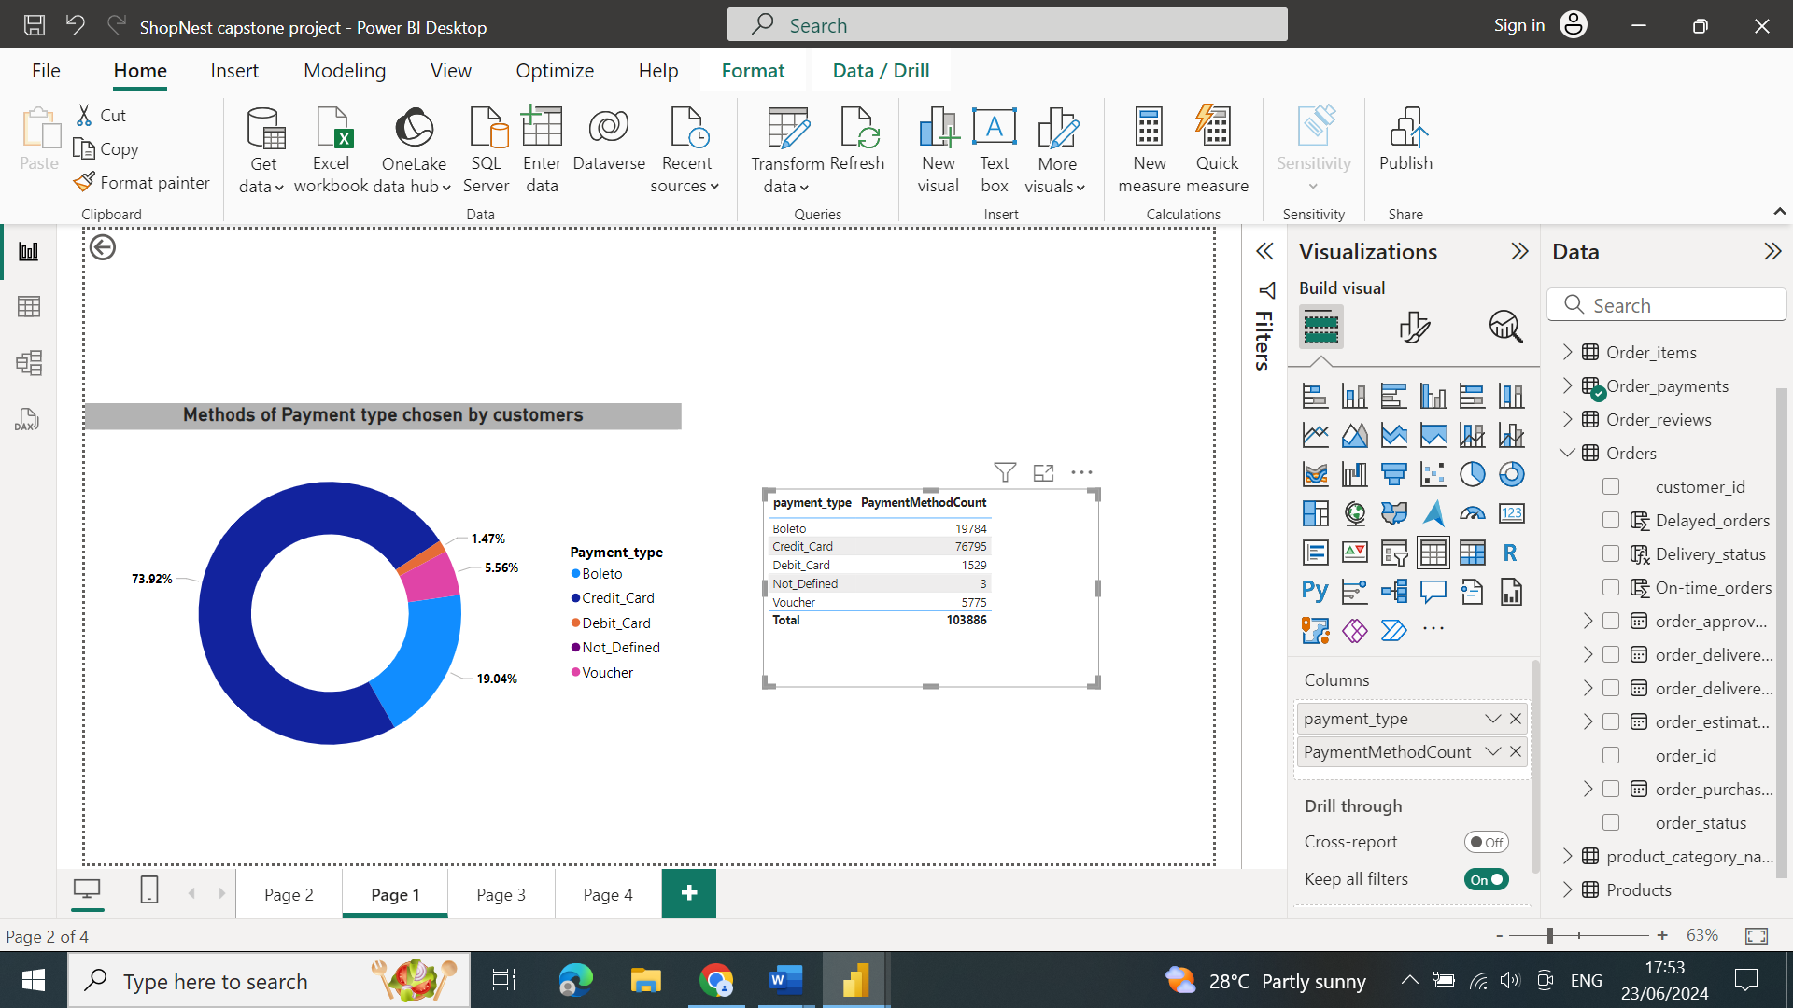

* **Explanation:**
* This Pie chart illustrates the various payment methods used by customers. **73.92% of clients paid with credit cards, 19.04% with Boleto, 5.56% with vouchers, and 1.47% by debit card.**
* By observing the segments of the pie chart, we can see the relative popularity of different payment methods. This helps in assessing **the need to support or improve less popular payment methods.**
* The analysis provides insights into **customer behavior** regarding payment preferences, which can inform **marketing strategies and payment processing improvements.**

## **5. Product Rating Analysis:**

* **Question Statement:** Determine the top 10 highest-rated products and the bottom 10 lowest-rated products using a bar or column chart.
* **Visualization:**

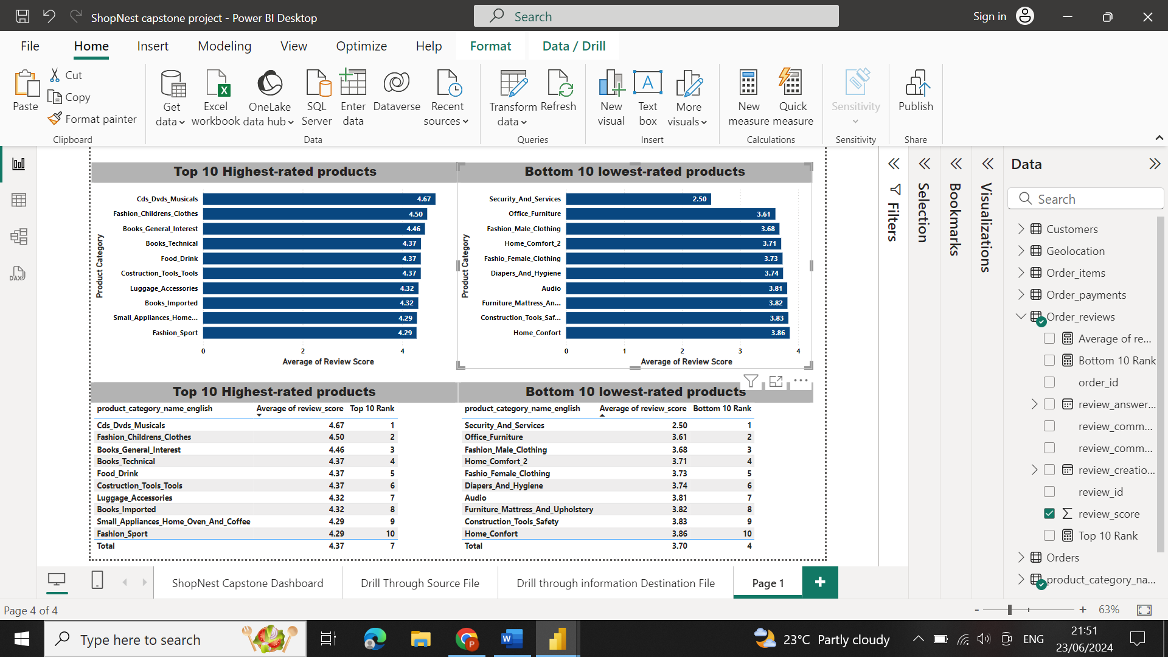

* **Explanation:**
* The visual clearly shows the top 10 highest-rated and bottom 10 lowest-rated products. This helps identify the products that are performing well and those that may **need attention or improvement**.
* By observing the average ratings, we can understand customer satisfaction and preferences. High-rated products indicate **good quality and customer satisfaction,** while low-rated products highlight areas for **potential improvement.**
* The comparison between high-rated and low-rated products can reveal patterns or commonalities in product features, **quality, or customer service that affect ratings.**

## **6. State-wise Sales Analysis:**

* **Question Statement:** Identify and visually represent states with high and low sales, providing a clear understanding of regional sales performance.
* **Visualization:**

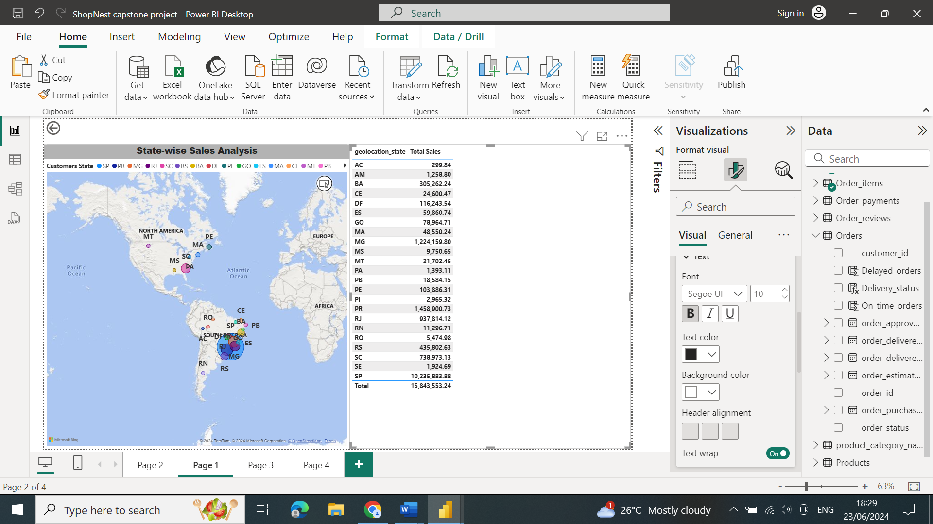

* **Explanation:**
* This graph displays state-specific revenue. The state of **SP had the greatest revenue**, **while RR had the lowest.**
* The visual clearly shows which states have high and low sales, providing insights into regional performance. This helps in identifying strong **markets and areas needing improvement.**
* By observing the colour intensity, we can see the distribution of sales across different states. High-intensity colours indicate high sales, while low-intensity colors indicate low sales, The low-sales areas might benefit from **targeted marketing campaigns or other strategic initiatives to boost sales.**
* Understanding regional sales performance can also **inform operational decisions, such as inventory distribution and logistics optimization.**

## **7. Seasonal Sales Patterns:**

* **Question Statement:** Investigate and visualize any seasonal patterns(Quarterly) or trends in sales data over the course of the year.
* **Visualization:**

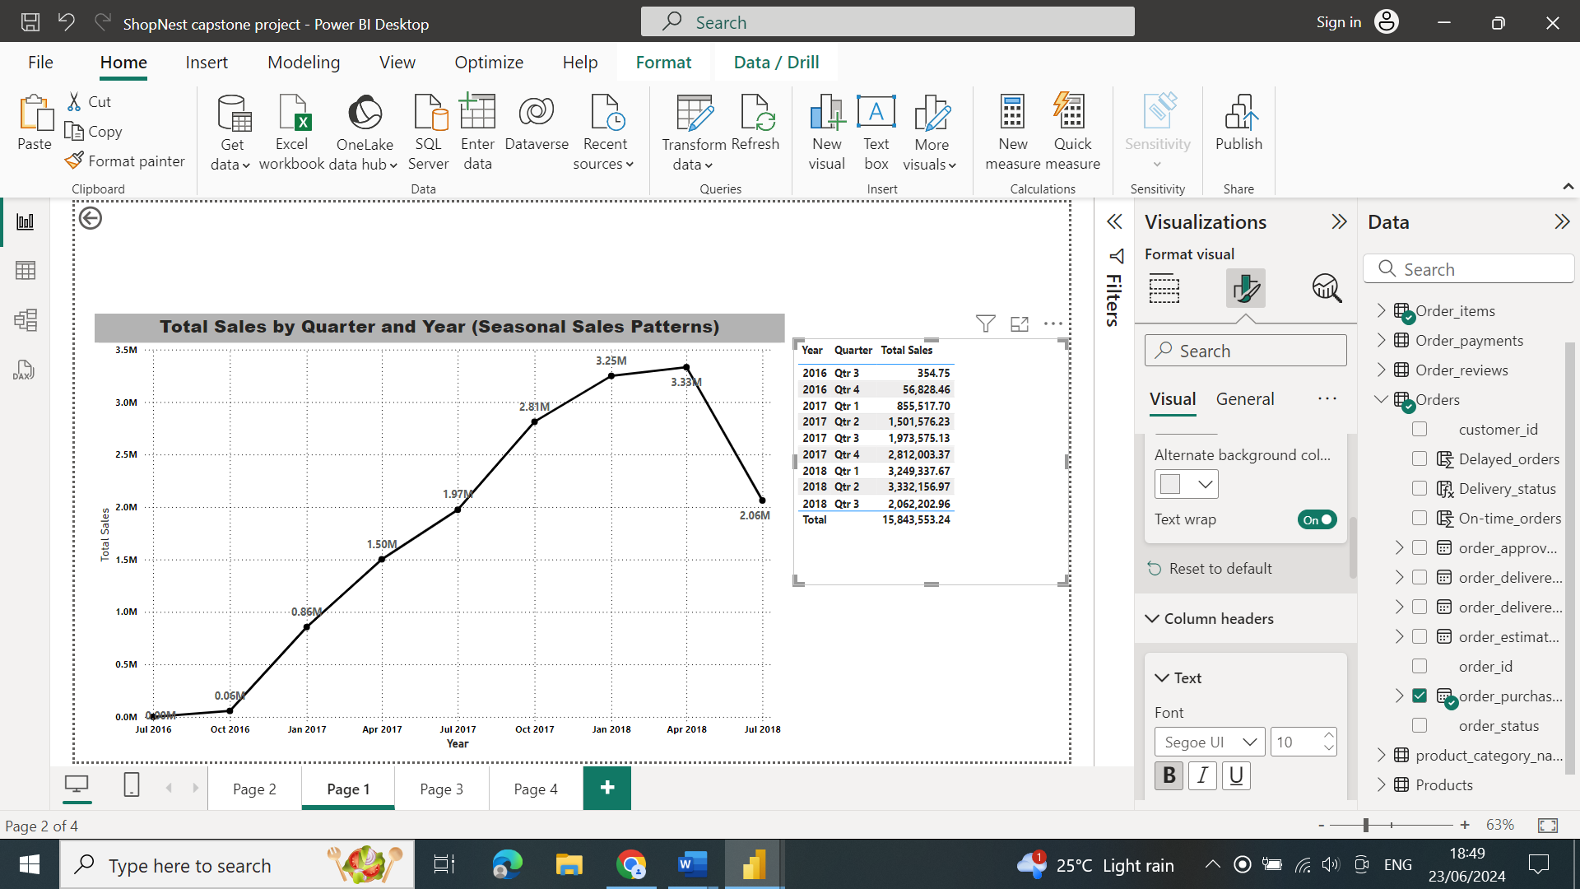

* **Explanation:**
* This graph provides information on quarterly sales. The second quarter **of 2018 had the highest revenue**, while the third quarter **of 2016 had the lowest revenue**.
* The visual will show how sales vary across different quarters, highlighting any seasonal trends. For instance, you might see a **consistent increase in sales during Q4 due to holiday shopping.**
* Understanding seasonal sales patterns can inform business planning, such as **inventory management, marketing strategies, and staffing requirements.**
* The visual can reveal peak sales periods and slower quarters, allowing for strategic **adjustments to optimize performance throughout the year.**
* By comparing the quarterly sales across multiple years, you can identify long-term trends and growth patterns. This helps in understanding how **sales performance is evolving over time.**

## **8. Revenue Analysis:**

* **Question Statement:** Determine the total revenue generated by ShopNest Store  and analyze how it changes over time(Yearly). Represent this information through suitable visuals to highlight trends and patterns.
* **Visualization:**

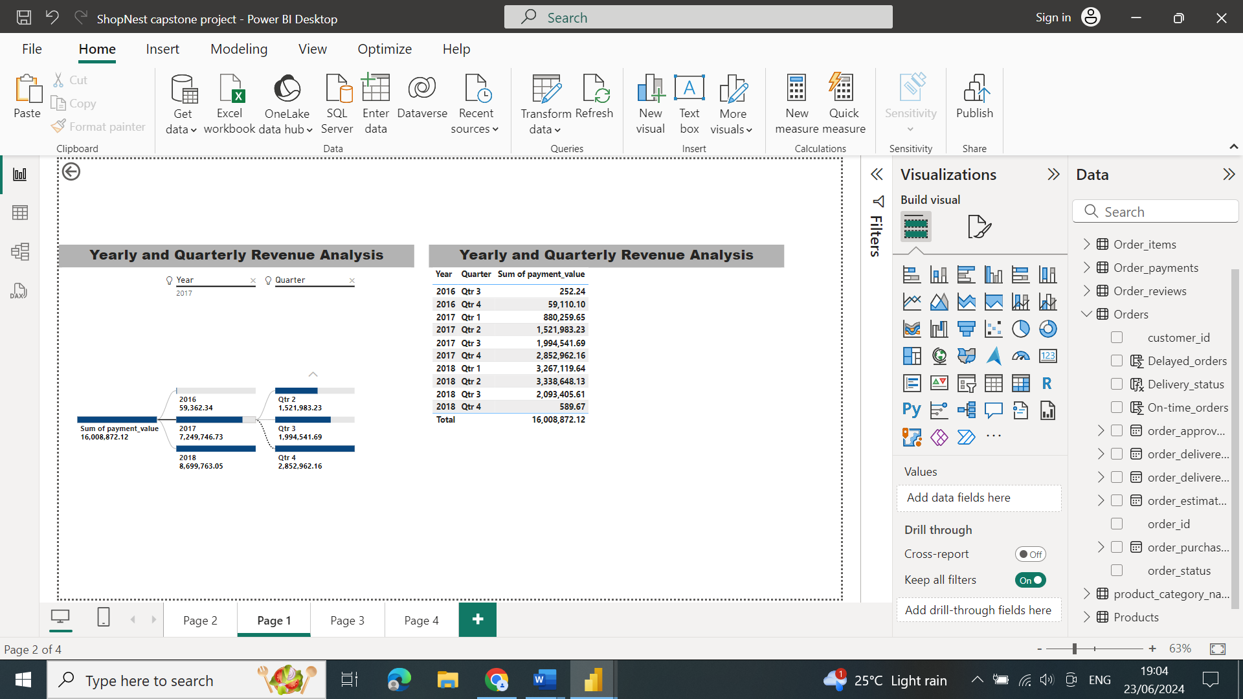

* **Explanation:**
* This graph displays the total revenue over time. By observing this graph, it is evident that the superstore's revenue has **increased year after year.**
* By observing the revenue trends over multiple years, you can identify periods of significant growth or decline, **helping to understand the factors driving these changes**.
* Analyzing the yearly revenue provides insights into the overall business performance of ShopNest Store, **allowing for strategic planning and decision-making**.
* The visual may reveal the impact of external **events (such as economic changes or market trends**) on the store's revenue, providing a broader context for the observed patterns.

# Conclusion:

***The analysis of Nexusgoods Superstore reveals several key insights:***

* **Top-Selling Products**: Certain product categories, such **as bed_bath_table** is highly popular despite issues with delayed orders.
* **Product Analysis**: A majority of products receive high ratings, though there is a notable percentage of low ratings, suggesting **areas for quality improvement.**

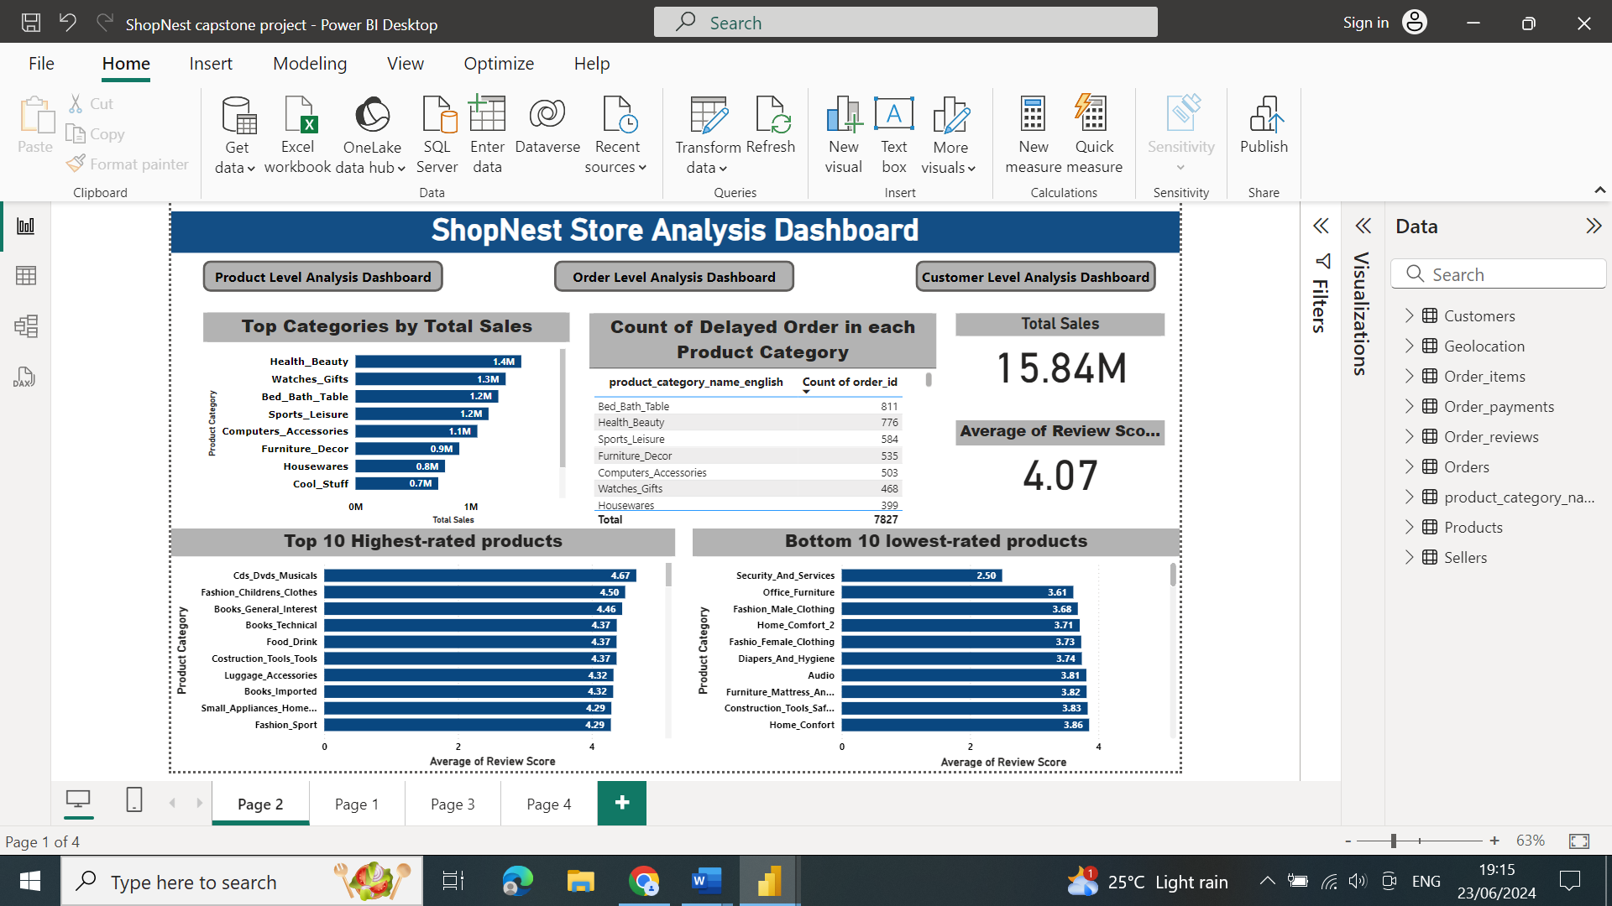

* **Order Timeliness**: While some months see a high number of delayed orders, other periods, particularly the **second quarter of 2018, demonstrate efficient delivery**.

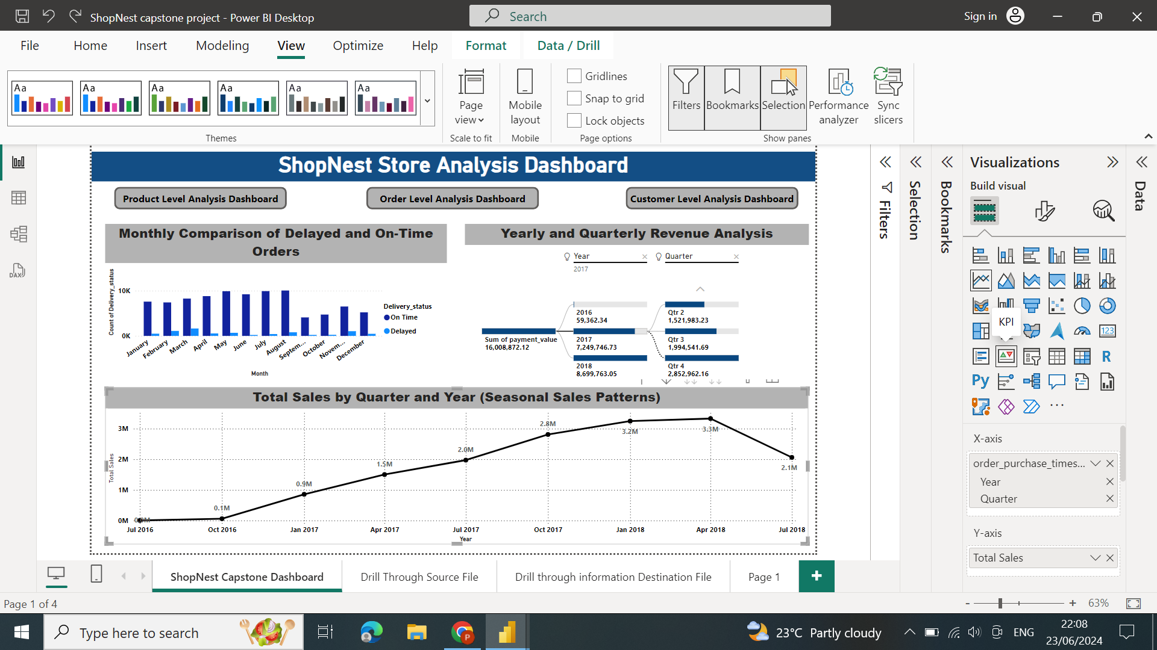

* **Customer Preferences**: Credit cards are the preferred payment method, indicating the importance of **maintaining secure and efficient credit card processing systems**.

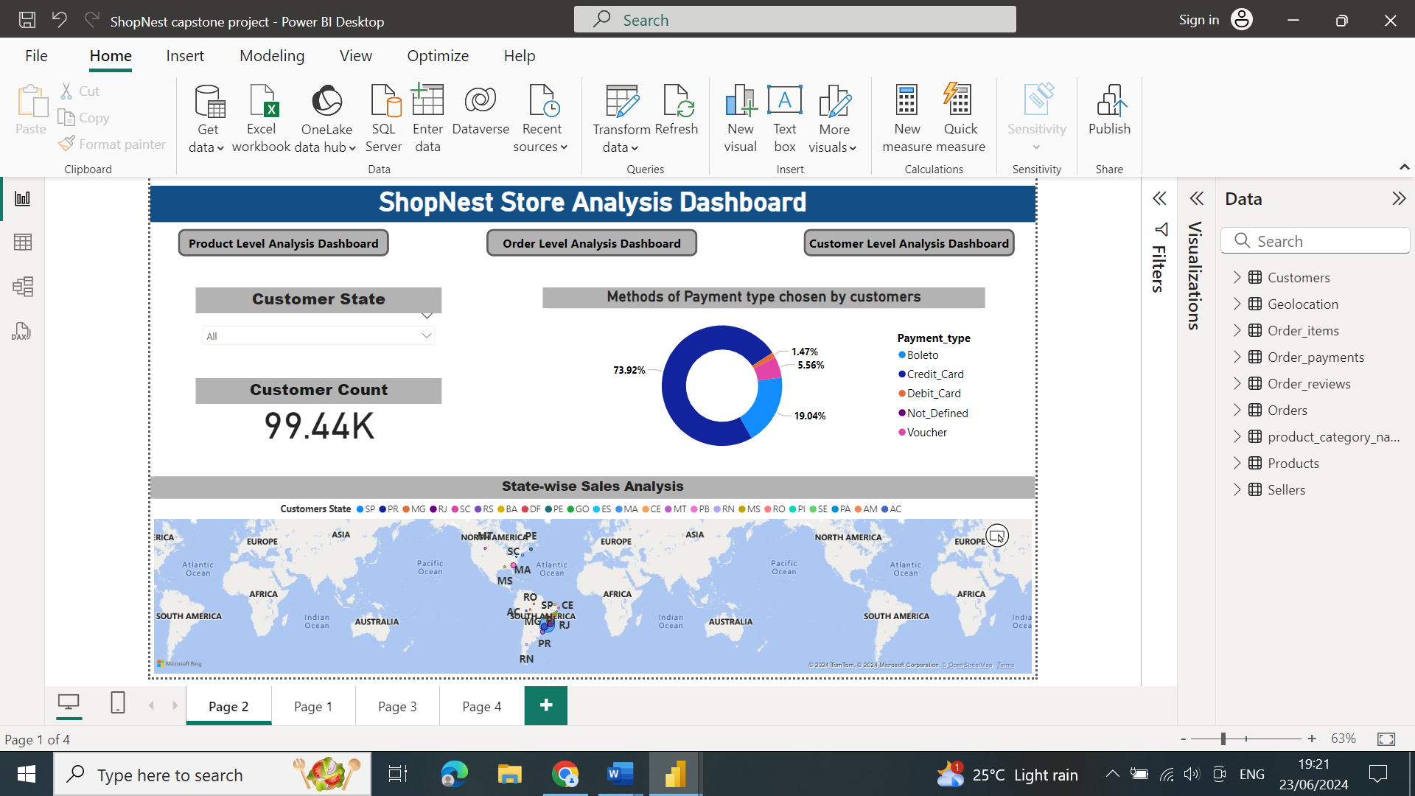

* **Sales Trends:** Revenue trends show positive growth, with certain periods and states **outperforming others.**

**By addressing areas such as delayed order reduction and quality improvement, Nexusgoods Superstore can continue to enhance customer satisfaction and drive further growth.**